Apply to become a Trustee

(updated 30/4/25)
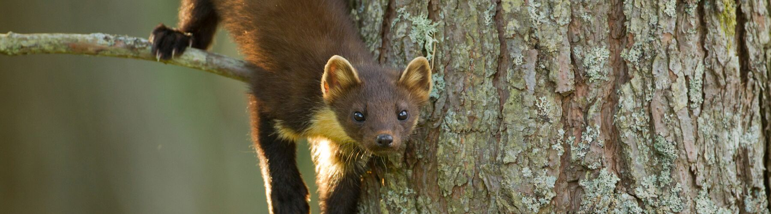
© Mark Hamblin / 2020Vision
We’re looking for Trustees who share our values and will bring fresh ideas to help keep us relevant and influential as we work to deliver our new three-year strategic plan. The Board of Trustees has four, three-year term vacancies in 2025.
We are particularly interested in hearing from you if you have knowledge and experience in any of the following:
- Natural heritage, ecology and land management
- Community engagement
- Finance and fundraising
- Environmental legislation
- Organisational development and project management
- Nature connection, green prescribing and outdoor education
We would like to encourage applications from diverse backgrounds.
If there are more than four candidates, election will be by ballot of members. Voting in a Members’ ballot will close on 1 August 2025 and the result announced at our AGM on Monday 15 September.

How to apply
To apply, you will need to:
- Complete a nomination form (including the Declaration of Fitness to Stand at the end) which must be supported by five proposers who are John Muir Trust Members;
- Enclose a candidate statement of up to 250 words. (NB You will be asked for a head and shoulders photograph of yourself to be used in the Trustee profiles on our website and our AGM materials, print and email newsletters.)
- Sign a copy of the Trustee Code of Conduct;
- Return these to the Returning Officer by email: returning.officer@johnmuirtrust.org

Closing date
Please send nominations to the Returning Officer’s email address above by 12 noon on Friday 6 June 2025.
Any questions can be emailed to the Returning Officer at the address above. Please ensure that your application is complete and includes all the above items. Candidates will be notified of the result before the AGM in September. We look forward to hearing from you!

Membership
Candidates and their proposers should be current members of the John Muir Trust and aged 16 or over. Candidates must have been Members of the Trust for 12 months or more unless they were earlier co-opted by the Board as Co-opted Trustees; proposers must have been Members of the Trust for 6 months or more. Members of the Trust can propose up to two candidates.

Proposers
Candidates should submit one nomination form containing the names and membership numbers of 5 proposers. If you would like assistance in connecting with potential proposers, please email returning.officer@johnmuirtrust.org. Any signatures that cannot be included on that form may be sent to the Returning Officer separately (by the above closing date) with the following wording:
'I support the nomination of as a Trustee of the John Muir Trust.'

Signature: ......................................... Name: ...............................................

Membership number (required): .................

Proposers should include their current membership number, which can be found on recent mailings.
Emailed nominations can be accepted, but only from email addresses in the John Muir Trust membership database.

Candidate statement
Please submit a statement of up to 250 words, outlining relevant experience and skills, including any work for the Trust, whether as Trustee, volunteer or member of staff. The statement should also indicate what you would hope to contribute as a Trustee.
You may find it helpful to see previous examples of statements. Statements for our current Trustees are on our website at www.johnmuirtrust.org/about-us/our-trustees
You may also like to refer to the Trust’s Strategy at www.johnmuirtrust.org/resources/334-our-strategy

Background information for candidates
The majority of Trustees are elected by the members of the Trust. Following the adoption of the Articles of Association at the 2021 AGM, up to 3 individuals, who must be members of the Trust, may be co-opted from time to time by the Board of Trustees itself, expressly to fill any perceived skills gaps identified within an annual skills analysis undertaken by all current Trustees. Please refer to Articles 7.4 and 8.1 for further detail on the arrangements for transitioning to the new composition of the Board.
Trustees play a key role in setting our policies and making strategic decisions. Board meetings are held four times a year (hybrid, online and in-person) and Trustees also meet in-person at Topical Forums (Trustee gatherings/away days) approximately four times a year. There are occasionally meetings to discuss important issues between these and extra commitments, such as Committees for some Trustees, these are usually held online. Our Trustee expenses cover travel, accommodation and subsidence.
New Trustees will receive an Induction and all Trustees are asked to complete some mandatory online training. There are also opportunities to attend CPD sessions to enhance knowledge in various areas.

Who can be a Trustee?
We are looking for Trustees aged 16 or over who have been a member of the Trust for 12 months or more unless you were earlier co-opted by the Board as Co-opted Trustees.
You will be asked to sign a Declaration of Fitness to stand, to confirm that you do not have an unspent conviction for dishonesty or an offence under the Act, or are an undischarged bankrupt, or have been removed under either Scottish or English Law or the courts from being a charity trustee or is otherwise disqualified from acting as a charity trustee or are disqualified from being a company director.
You will also be asked to sign the Trustee Code of Conduct.

Extracts from the Articles of Association

Casual Vacancy of a Trustee
8.4 In the event of a casual vacancy arising as a result of the retiral or deemed retiral of an Elected Trustee (in terms of Article 8.5), the Board may not fill that vacancy, which will instead fall to be filled for the remainder of the retired Trustee’s original Term of Office by election at the next AGM through the normal Trustee election process, as specified in Articles 8.2.8 – 8.2.10.

Election timetable & process
8.2.3 The Board shall ensure that, at least 90 clear days before the date of the AGM, members shall be notified of the number of vacancies in the Board and the closing date for nominations of Trustee candidates (which shall be at least 36 clear days prior to the AGM). Where appropriate, the Board will, using the annual skills analysis undertaken by all current Trustees, inform members of any specific skills gaps identified within the context of the overall effectiveness of the Board.
8.2.8 If the number of Trustee candidates does not exceed the number of vacancies for the election of Elected Trustees, those candidates are duly elected without the need for a vote.
8.2.9 If the number of Trustee candidates exceeds the number of vacancies, and a vote of members is required, election shall be by ballot only (which can be conducted by post, e-mail and/or other electronic means approved by the Board prior to the AGM), with each member who is eligible to vote using the Single Transferable Vote procedure described in Schedule 4 to these Articles.
8.2.10 The Returning Officer shall ensure that a ballot paper listing, in random order, the names of all nominated Trustee candidates (and their supporters) be sent to members at least 28 clear days prior to the AGM, together with the nominee’s Candidate Statement and any biographical details submitted. Where a vote is necessary, this will be accompanied by an explanation of how each member can vote (by post or e-mail or other appropriate electronic means) by a specified closing date for voting (which shall be at least 5 Working Days prior to the AGM).

Remuneration of Trustees
10.4 No benefit (whether in money or in kind) shall be given by the Trust to any member or Trustee except, subject to section 67 of the Charities Act, the possibility of: 10.4.1 repayment of out-of-pocket expenses to Trustees (subject to prior agreement by the Board)

Useful documentation
Trustee documents are available at: https://www.johnmuirtrust.org/resources/331-trusteecall
These include:
- Nomination Form (including Declaration of fitness to stand as Trustee)
- Trustee Code of Conduct declaration
Governance and related documents are available at: https://www.johnmuirtrust.org/resources/335-governance-library
These include:
- Articles of Association
- Standing Orders
- Information about Board Operations
For further information, please access the Guidance and Good Practice for Charity Trustees from OSCR, the Trust’s Regulators at www.oscr.org.uk/media/3621/v10_guidance-and-good- practice-for-charity-trustees.pdf

